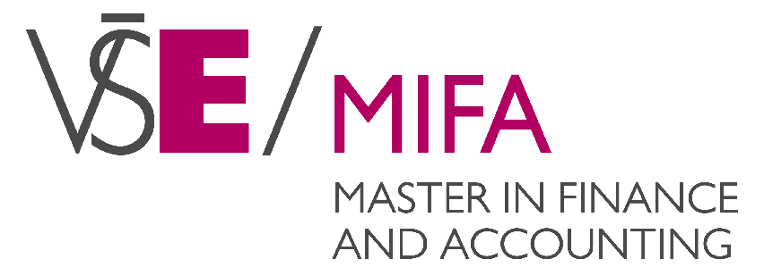
Master programme Finance and Accounting
Faculty of Finance and Accounting
Prague University of Economics and Business
Application Form for Academic Year 2022/2023

Personal Information:
☐ Mr. ☐ Ms.  First Name: | Birth Registration No (if applicable):
Family Name: | Date of Birth (day – month – year):
Maiden Name: | Place of Birth:
Nationality: | Country of Birth:
Citizenship: | Identity Card No(if applicable):
Residence Permit No: | Country of Passport and Passport No:

Contact:
E-mail: | Telephone:

Contact Address (address you are reachable via the admission procedure) *):
Street, House, No.:

City:

Postal Code: | Country:

Highest Level of Completed University Education:
Planned date of the bachelor´s graduation (if your study hasn´t been finished):
School/University:

Faculty:

Major Area of Study:

Address:

Degree Achieved:

Year of graduation: | No. of years of work experience related to specialisation:

I am interested in:
(more than one answer possible)
☐ REGULAR MIFA programme
(two year programme structure at VSE)

☐ Double Degree at UCL Belgium
(one year at MIFA and the second year at a partner University)

☐ Double Degree BAMBERG Germany
(one year at MIFA and the second year at a partner University)

Entrance Examination:
I apply for in person interview at the Faculty of Finance and Accounting in Prague:
☐ YES ☐ NO

Language Knowledge:
English native speaker: ☐ YES ☐ NO

Previous university education fully in English: ☐ YES ☐ NO ; Details:

Accommodation:
I apply for the accommodation of the dormitory of the Prague University of Economics and Business:
☐ YES ☐ NO

Buddy:
I apply for a Buddy service after my arrival to Prague (offered for international students accepted to the program):
☐ YES ☐ NO

Student VISA:
I need to apply for the Student Visa: ☐ YES ☐ NO
If yes, please fill in the shipping address where to send the Visa documents:
Street, House, No.:

City:

Postal Code: | Country:
To speed up the Visa procedure we may offer you to send the documents to the above address via FedEx. We highly recommend this service as it is the most reliable way.

Would you like to receive the documents via FedEx?:
☐ YES ☐ NO

Note: In case of your interest in this option the charges of this service are payed by the applicant.

Where did you find information about the MIFA program?
☐ MIFA websites
☐ Other (Please be specific):

I declare that all the above given data are correct. I declare to pay tuition fees when
E-application is opened.

Date: Applicant’s Signature: ...........................................

Required documents:
1) Official copy of a recognition of the previous university degree; official copy of a diploma and a transcript (if the degree is not completed: confirmation of study, temporary transcript)
2) Curriculum Vitae (CV) in English including your photo
3) National ID or passport copy
*) Please, fill in the permanent address (official) into the e-application!

INSTRUCTIONS

- Mail this form to: mifa@vse.cz
- Send this signed paper application form together with other required documents to the following address:

Prague University of Economics and Business
Faculty of Finance and Accounting
MIFA Master Programme
nám. W. Churchilla 4
130 67 Praha 3

